Secure Shell (SSH)Theory (1 hour): Importance of SSH for secure communication. Configuring and securing SSH. Practical (1 hour): Configure SSH with key-based authentication. Task: Disable password login and document the
configuration.

Tasks

1. Install the OpenSSH server package on your Linux system and verify that the sshd service is running by connecting to localhost using the ssh command.

ANS:

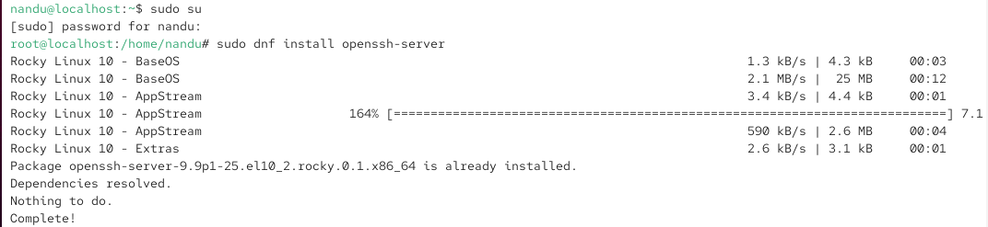

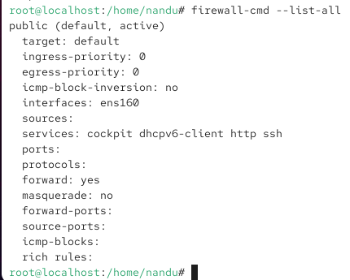

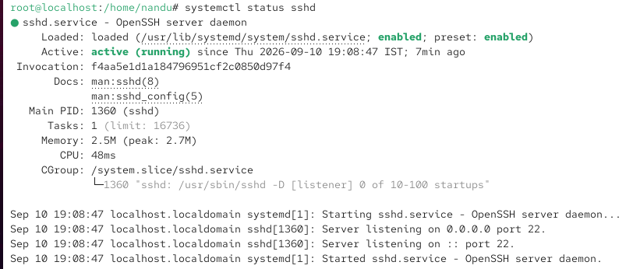

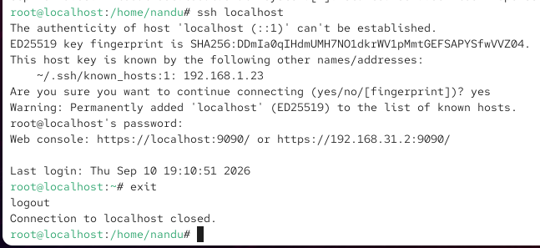

2. Generate a new SSH key pair using ssh-keygen, and add your public key to the ~/.ssh/authorized_keys file of your user account to enable key-based authentication.

ANS:

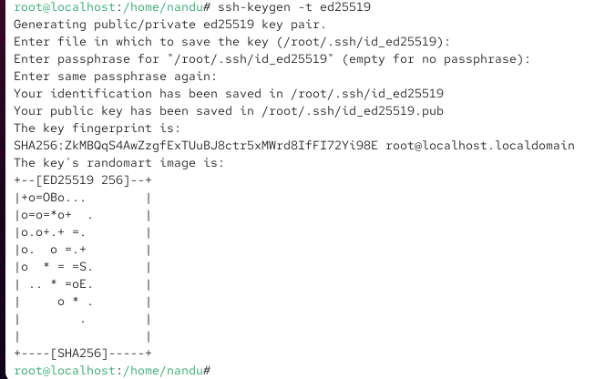

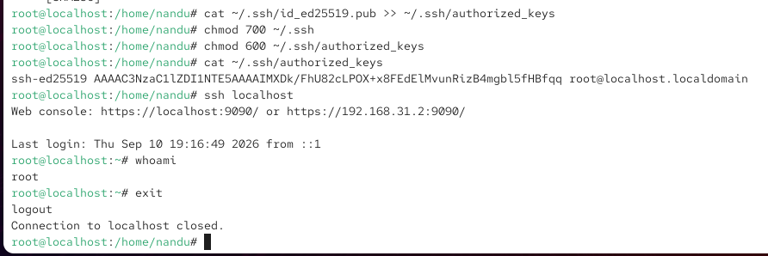

3. Edit the /etc/ssh/sshd_config file to disable password authentication by setting PasswordAuthentication no, then restart the sshd service and test that you can only log in using your SSH key.

ANS:

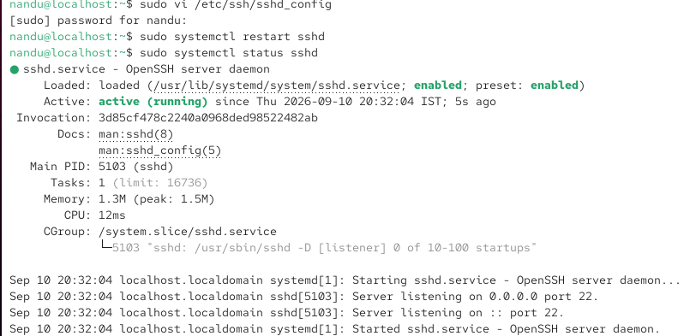

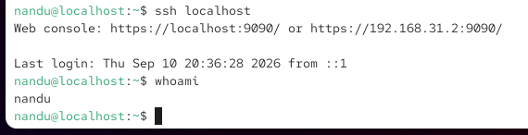

4. Document each step you took to configure SSH key-based authentication and disable password login, including the exact commands and configuration changes you made Use screenshots or command outputs to support your documentation.

ANS:

1. Verify SSH Service

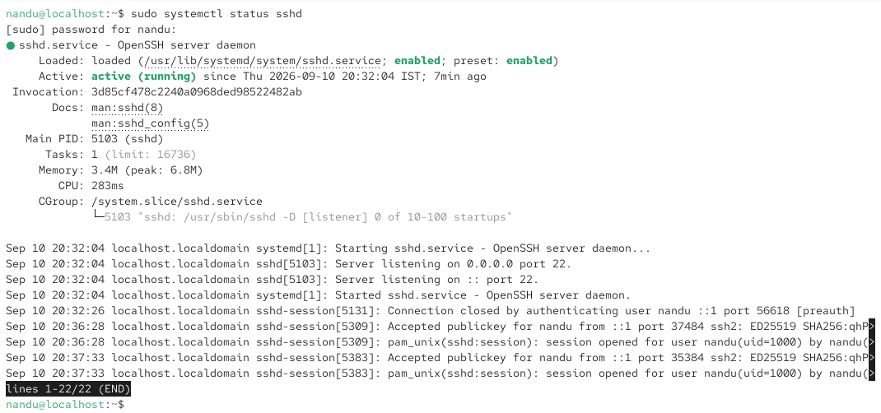

2. Generate SSH Key Pair

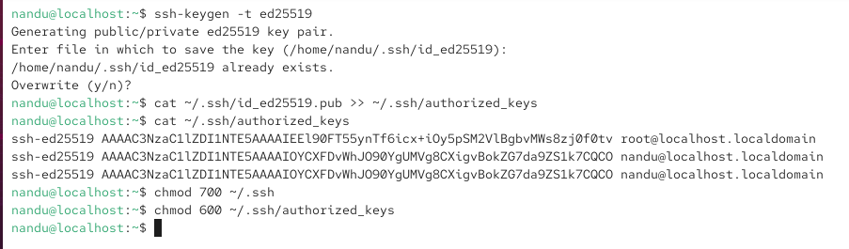

3. Disable password login

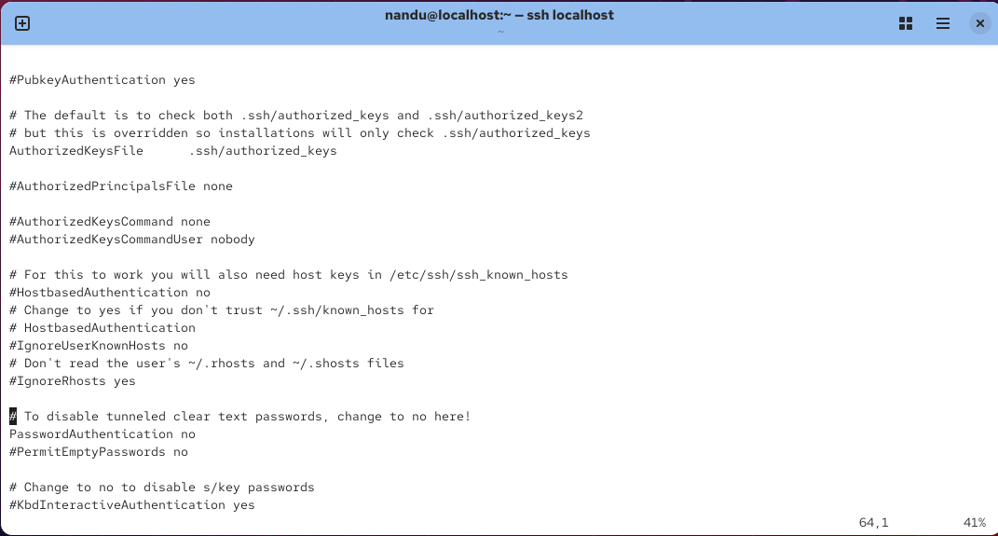

4. Restart SSH Service

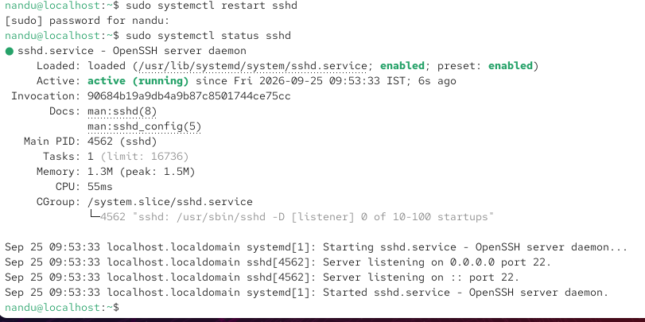

5. Test SSH Key Authentication

